**UNIVERSITY OF HYDERABAD**

Gachibowli, Telangana - 500046



School of Computer and Information Sciences (SCIS)

University of Hyderabad

Spring 2019

**Final Report**

**on**

**Online Examination System**

**Submitted to: Submitted By:**

Dr. Abhishek Kumar Thakur G HAREESH

IDRBT 18MCMB15

HYDERABAD MTECH (IT)

UNIVERSITY OF HYDERBAD

Contents

**1. Introduction**

1.1 Purpose

1.2 Scope

1.3 Definitions, Acronyms, Abbreviations

1.4 References

1.5 Overview

**2. Project Management Plan**

2.1 Team

2.2 Schedule

2.3 Risk

2.4 Release and change Management

**3. User Requirements + Non-functional Requirements**

3.1 User Requirements

3.2 Non-functional Requirements

**4. System Architecture + Functional System Requirements**

4.1 Functional Requirements

4.2 Hardware Requirements

4.3 System Architecture

4.3.1 Product functions

4.3.2 User Characteristics and Constraints

4.3.3 UML Diagrams

**5. Test Cases**

**6. References**

**1. INTRODUCTION**

**1.1 Purpose**

The purpose of the project is to provide online facility to *Institutes* to conduct online exams and to Students to give online exams. Institutes can enter and edit the questions along with the students list. Also they can view the result. Students can login and give their respective exams and view their score then and there. *Others* can view sample papers to get look and feel of the online examination system.

**1.2 Scope**

The website to conduct online examination is “Online Examination”. This website provides facility to institutes to conduct online exams by providing a unique id to each institute. The institute provides questions along with positive and negative marks. Institute also enters the list of eligible students. All the information entered can be later edited by the institute.

In turn student can login with their id, name and institute id to give the exams and can view their result then and there. Institutes can also view the result of their students.

**1.3 Acronyms, Abbreviations, References**

JSP stands for Java Server Pages

DBMS stands for Data Base Management System

HTTP stands for Hyper Text Transfer Protocol

CSS stands for Cascading Style Sheet

This web application has been prepared on the basis taken information from following websites,

Google.com, Wikipiedia.org.

**1.4 Overview**

The rest of this document describes the various project management plan, system requirements, interfaces, features and functionalities in detail.

**2. Overall Description**

In Online examination system institute can register to conduct an online test and view the records later. Students can give the test and their respective records, which include their marks for each test given by them, will be maintained separately. No student can take a particular exam more than once.

**2.1. Product Perspective**

(i) User interfaces:

The application will have a user friendly and menu based interface.

Following screens will be provided:

(ii) A login screen for entering the username, password will be provided. Access to different screens will be based upon the user.

(iii) There is a screen for displaying information regarding entries to be made by institutes.

(iv) There is a screen for displaying information regarding filling of exam details by institutes.

(v) There is a screen for displaying information regarding entering student list for the particular exam.

(vi) There is a screen for displaying information menu regarding what options the institutes will select while filling entries (entering questions, student list, deleting questions, entering exam details).

Project Report on Online Examination System

(vii) There is a screen for displaying exam details to the students when they are taking exams.

(viii) There is a screen for taking exam for the students.

(ix) There is a screen for displaying of results of students after taking the exam.

*(x) Hardware interfaces*

(i) Support for printer for printing results then and there.

(ii) Screen resolution of at least 800X600 is required for proper and complete viewing of screens. Higher resolution will be accepted.

*(xi) Software interfaces*

(i) Any windows based operating system.

(ii) MS Access 2000 as the DBMS-for database.

(iii) IDE (NET BEANS,ECLIPSE) for developing code.

(xii) Communications interfaces None

(xiii) Memory Constraints At least 512 MB RAM and 5 MB space on hard disk will be required for running the application.

(xv) Site Adaptation Requirements Web browser with cookies enabled.

**2.2. Product Functions**

The website will allow access only to authorised users with specific roles (Administrator- maintains the website, Institutes-Register to conduct the exams, Students-Give the exams online)

A summary of the major functions that the website will perform:

a. Provide facility to institutes to register to conduct an online test.

b. Institutes can enter the number of questions, +ve, -ve marks, questions and answers and the list of eligible students.

c. Students can login and give the tests.

**2.3. User Characteristics**

a. Educational level: Users should be comfortable with the English language.

b. Experience: Users should have prior information regarding the online examinations.

c. Skills: user should have basic knowledge and should be comfortable using general purpose applications on computers.

**2.4. Assumptions and Dependencies**

The examinations are all objective. Students can give each exam just once.

In general it has been assumed that the user has complete knowledge of the system that means user is not a naïve user.

Any data entered by him/her will be valid. To make the software as user friendly as possible but at the same time keeping in minds user requirements.

It depends that the one should follow the international standards for the generating the User ID & should fill the related information in the proper format.

**3. Project Management Plan**

This section will go over Project management; what should the team be like and the project schedule, risk management, and configuration control.

**3.1 Team**

|  |  |  |
| --- | --- | --- |
|  | **Job Title** | **Description** |
| **1** | Project Manager | * To manage all processes in the project |
| **2** | SW Designer | * To design the models and diagrams that helps the programmer in implementation phase. |
| **3** | Two Testers | * One from outside the team and the other from the inside the project team. |
| **4** | Two programmers | * Professional in ASP.NET and SQL * To programming the processes of the project. |
| **5** | SW Analyst | * To analyze the requirements of On-Line Exam System. |
| **6** | Writer | * Collects drafts from each member. * Rewrite and reformate the documents come from each member. * Have good print skills. * Have a good skill to correct grammars of statements. |

**3.2 Schedule**

|  |  |
| --- | --- |
| **Days** | **Tasks to be done** |
|  |  |
| 1 | Analysis and Planning |
|  |  |
| 2-3 | Requirements gathering |
|  |  |
| 4-5 | Design |
|  |  |
| 6-10 | Code(Frontend and Backend) |
|  |  |
| 11-12 | Testing |
|  |  |
| 13-14 | Deployment |
|  |  |

**3.3 Risk Analysis and Risk Planning**

|  |  |  |  |
| --- | --- | --- | --- |
| **Project Risks:** | | | |
| **Risk** | **Probability** | **Effects** | **Risk planning strategy** |
| The experience staff in the team leave the project before it is finish, or someone was ill | low | serious | Use more than one staff for each section, which might minimize this risk. Also, manager tries to increase salary for him. |
| The methodology to solve the problem can't work in a proper manner. | high | serious | Must be study more than one methodology to minimize this risk. |
| Budget does not enough or there is no budget. | low | catastrophic | Put a condition in the contract if there any more expenses, the funded side must be pay it. To avoid this risk. |
| HW requirement can't come in the time. | moderate | serious | See if there is any more time to delay the project or not. If there is no more time work by the team computers, to minimize this risk. |
| **Product Risks:** | | | |
| **Risk** | **Probability** | **Effects** | **Risk planning strategy** |
| Packages and Development tools does not enough. | high | serious | Put a condition in the contract to increase the time of project delivery depends on the problem occur. To avoid this risk. |
| Can't found the suitable components. | high | tolerable | Programmer must have professional programming skills to write a new code, which minimize this risk. |
| **Business Risks:** | | | |
| **Risk** | **Probability** | **Effects** | **Risk planning strategy** |
| Can't found the suitable place for meeting the team. | moderate | tolerable | Monitoring the work by E-mail every day. To avoid this risk. |
| Damage the electricity generator. | high | serious | There is a spare generator to avoid this risk. |
| Marketing the product system. | low | catastrophic | Distribution of advertisements, which minimize this risk. |

**3.4 Release and Change Management**

1. First release can be done after completion of project then we release the product

2. If it is working properly then its ok and in case any problem occur in that product after 10 days.

3. Other versions can be started to modify errors, risks of previous release or can release with updated software.

4. It should be merged properly with the previous release and should be configured properly.

5. If product is failed then change immediately.

6. If product is not recognize any person face in examination centre then immediately change.

**4. User Requirements**

The user requirement for this system is to make the system fast, flexible, less prone to error, reduce expenses and save the time.

* Time can be saved by scheduling the exams, if it is available a question bank to store questions for different subjects.
* A system can be given a mark by checking the students answers, and give the result as soon as students finish his exam.
* A facility to generate a result chart as pre required without manual interface.
* The system should have records of students and faculty that can be access to the system which can be used only for the authorized person.
* The system should be more secure for management user records and more reliable to work at any conditions.

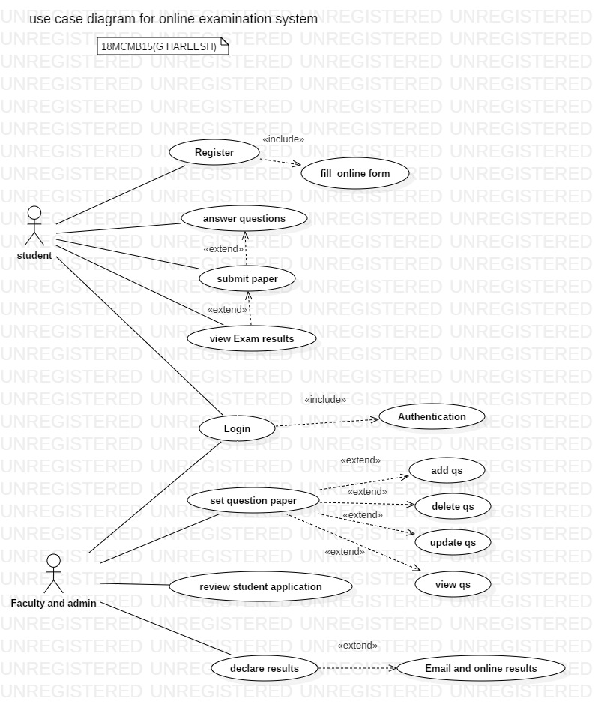

**4.1 Non Functional Requirements**

**1. Security**

Application will allow only valid users to access the system. Access to any application resource will depend upon user’s designation. There are two types of users namely Administrator and Student. Security is based upon the individual user ID and Password.

**2. Reliability**

The Application should be highly reliable and it should generate all the updated information in correct order.

**3. Availability**

System will be available around the clock except for the time required for the back up of data.

**4. Maintainability**

The installation and operation manual of examination management system will be provided to the user.

**5. Portability**

The application should be portable on any windows/Linux based system

1. **System Architecture + Functional System Requirements (SMART) :**

**5.1 Functional system Requirements**

This section gives a functional requirement that applicable to the On-Line Exam system.

There are three sub modules in this phase.

* Candidate module.
* Examiner module.
* Administrator module.

**The functionality of each module is as follows:**

* **Candidate module**: The candidate will logon to the software and take his examination. He can also check his previous examinations marks and his details. The candidate will get result immediately after the completion of the examination.
* **Examiner module:** The database is prepared & loaded into the software. Selection for examination can be done language wise by the examiner. The results will be displayed immediately after completion of the examination.
* **Administrator module:** The administrator collects all the results after successful completion of the examination and sends to the head quarters as and when required.

**The features that are available to the Administrator are:**

* The administrator has the full fledged rights over the OES.
* Can create/delete an account.
* Can view the accounts.
* Can change the password.
* Can hide any kind of features from the both of users.
* Insert/delete/edit the information of available on OES.
* Can access all the accounts of the faculty members/students.

**The features available to the Students are:**

* Can view the different categories of Test available in their account.
* Can change password.
* Can view their marks.
* Can view the various reading material.
* Can view and modify its profile but can modify it to some limited range.

**The features available to the Examiner are:**

* Can view the different categories of Test conducted by users.
* Can change password.
* Can view their marks.
* Can view and modify Results.

**5.2 UML Diagrams**

**DFD Diagrams**

**DFD Level 0, 1&2:**

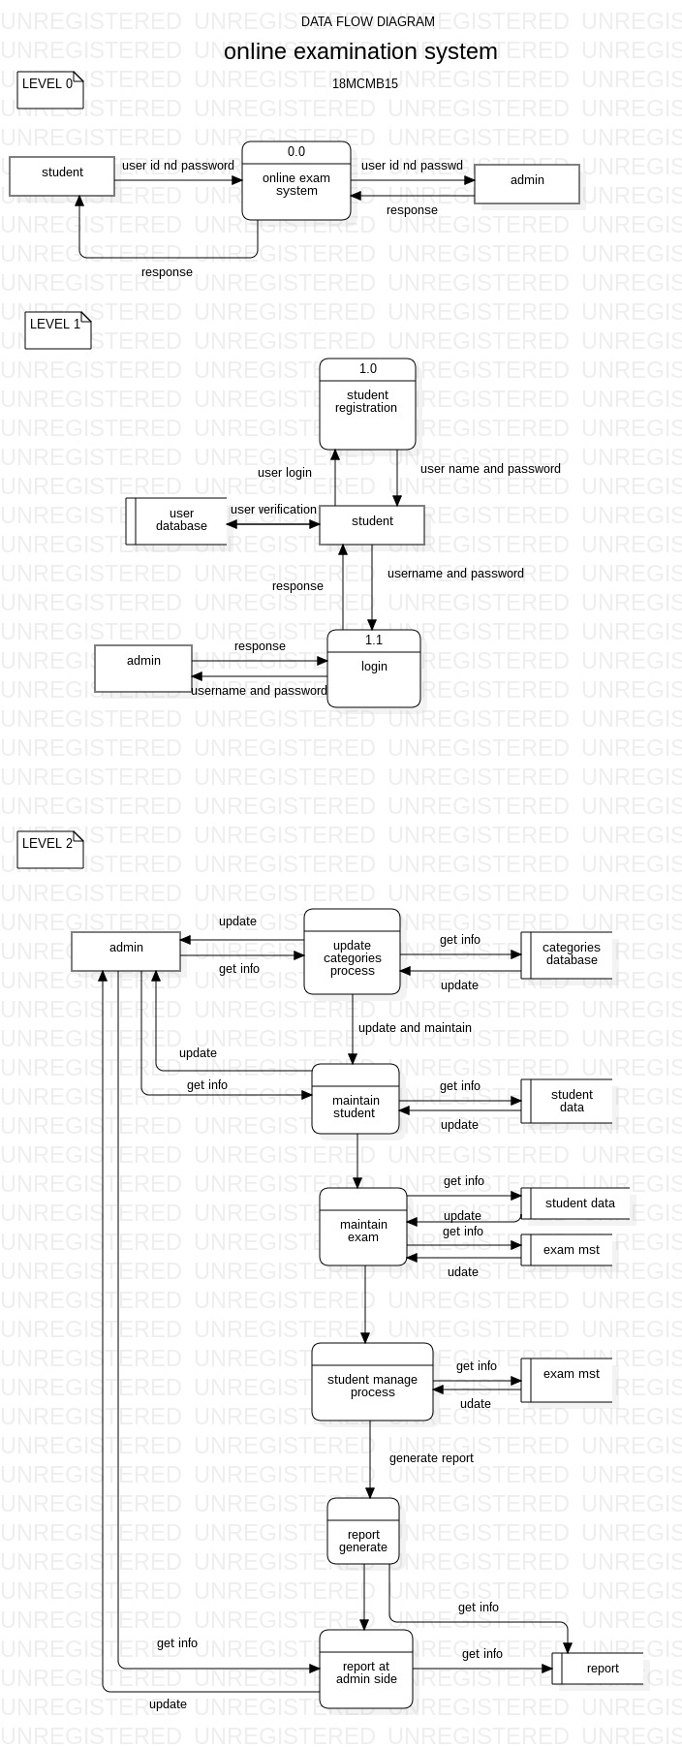

**UML DIAGRAMS**

**ER Diagram:**

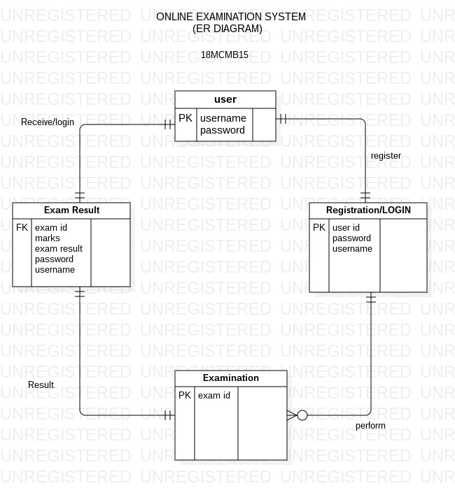

**UML DIAGRAMS**

**Sequence diagram:**

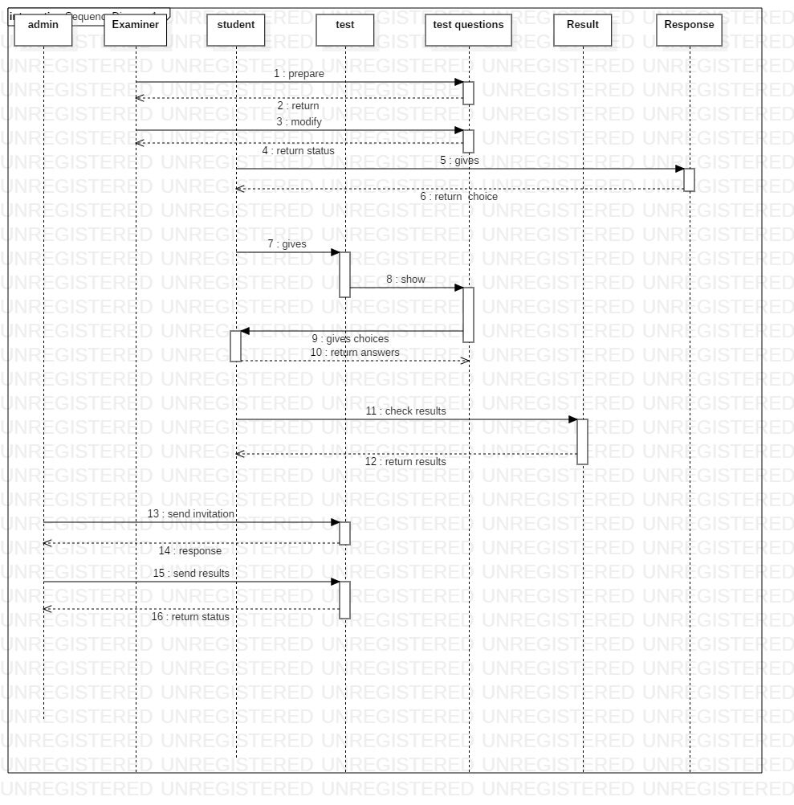

**6. Test Cases:**

**Test scenarios for setting exam functionality**

1. Verify that the application has portal to add subject wise questions and their options.
2. Verify that the examiner can set the examination details like 'Exam Name', 'Subject', 'Exam Code' etc.
3. Verify that the examiner can set the total number of questions and based on the number of questions, the examiner is presented with the window to add question details.
4. Verify that examiner can set details for each question - Question, Options, Marks etc.
5. Verify that examiner can set or leave the option of negative marking.
6. Verify that the examiner can set the passing marks for clearing the exam.
7. Verify that examiner can set time duration for the whole exam or for individual questions if required.

**Test scenarios for student section**

1. Verify the student can choose the examination based on the exam name or code.
2. Verify that the student should see the options to fill the required details like name, roll number etc before starting the exam.
3. Verify that after filling the required details user should see the option to begin the exam along with instructions.
4. Verify that once the examination begins a timer gets started based on the test duration.
5. Verify that for each question user is presented with option for multiple choice questions (MCQ) type questions.
6. Verify that user can chose single (radio button) or multiple (checkbox) option based on the type of questions.
7. Verify that on question's window user is presented with options to move to previous or next question.
8. Verify that once all the questions are answered or passed user can end the test.
9. Verify that if the time duration for the test gets reached the test automatically ends.
10. Verify that once the test is submitted, the test evaluation is performed considering the positive and negative marking.
11. Verify that on evaluation user is presented with Pass/Fail status along with Marks secured, questions attempted etc.



**7. References:**

<https://www.tutorialspoint.com/ms_sql_server/> <https://www.w3schools.com/>

https://www.scribd.com/document/29149055/Software-Engineering-Online-Exam-System

https://www.codeandpixels.net/online-examination-system?pg=online-examination-system